ZHEJIANG UNIVERSITY OF TECHNOLOGY
COLLEGE OF INFORMATION ENGINEERING

SIGNALS & SYSTEMS

LABORATORY MANUAL

Liping CHANG , Tao WU and Sheng Li

September 2013

Contents

Preface
Contents 2
Preface 3
Experiment I: Introduction to MATLAB 4
Experiment II: Time-domain Approach to LTI Systems 14
Experiment III: Introduction to MATLAB Spectral Analysis and Filtering 22
Experiment IV: Signal Sampling and Reconstruction 30

Preface

This laboratory manual is designed for the subject Signals & Systems. It contains four experiments, each requiring 2 hours.

The objective of this laboratory is to enhance the concepts provided in the subject, particularly to help students have a better understanding of LTI systems, frequency response & filtering, and signal sampling & reconstruction with different multimedia signals.

The experiments are carried out on the platform of MATLAB. As one of our teaching purposes, students will learn the basics of this popular and powerful software.

In the previous version, Experiments I & II were designed by Mr. Tao WU, while Dr. Liping CHANG took charge of Experiments III & IV as well as editing the entire manual. Dr. Sheng Li contributes for a revision of the entire manual, which leads to the present version of the manual.

We hope every student will share his or her own code for others and exchange ideas during the course. We will be very pleased and grateful when accepting your contributions. SHARE and PROGRESS are most significant things in this class.

Experiment I: Introduction to MATLAB

Objective
Learn how to generate signals in MATLAB, use the basic control statements, plot figures in MATLAB and write MATLAB file to complete some simple missions.

Procedure

Preliminary of MATLAB:

Representing a signal
As a function, a signal is usually described using figures/plots and very often by closed-form expression. In this part, we will start learning MATLAB and try to use it to describe a given signal with figures or expressions.
We can enter MATLAB by double clicking the icon ‘MATLAB’ on your desktop. Then, you should arrive at the following user-interface:
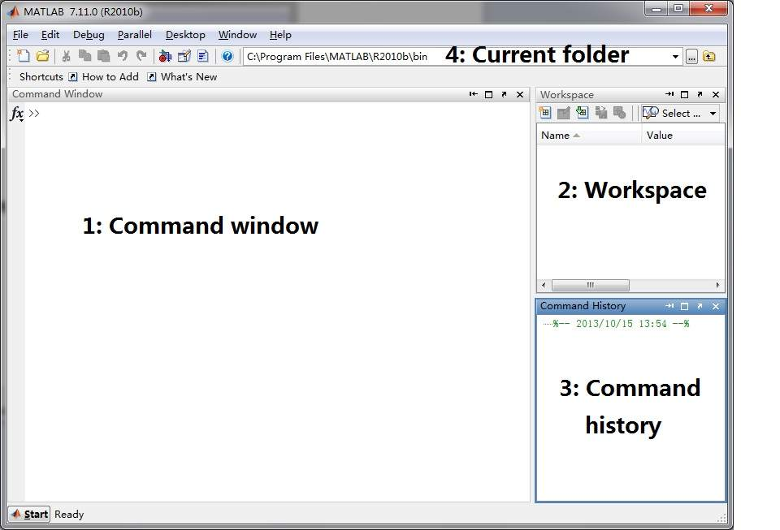
There are four sections we would like to explain:
1: Command window
Here is the place you can enter MATLAB command. You can see the symbol ‘>>’ before each command-line. Throughout this manual, the commands with such a symbol means the commands typing in the Command window, e.g., >> a = 1.25+ 2.36*j, means type a = 1.25+ 2.36*j in the Command window.
2: Workspace
Workspace consists of the variables you have created and stored in memory during a MATLAB session. Always keep an eye on the workspace, you can track the variables you have obtained and check if everything goes on well.
3: Command history
All the commands that were typed in the Command window will be displayed in Command history.
4: Current folder
A MATLAB function must be located in the current folder to enable a function call.

Now, we can try to generate some signals in MATLAB! It should be noted that data can be entered into MATLAB as a scalar quantity, a vector, a matrix and a multidimensional array or tensor. For example, typing the following commands in the Command Window:

>> a = 1.25+ 2.36*j ; b = cos(pi/3)

We have defined and assigned the values to the variables ‘a’ and ‘b’ that are both in a scalar form. After typing these commands, press Enter and you will find both ‘a’ and ‘b’ have been stored in the Workspace. Note that, we have not defined the variables j and pi before. We can use them directly because these words are recognized as special words in MATLAB. For example, j is a complex operator in MATLAB (i.e., j*j= -1). There are many other special words in MATLAB that have specified meaning, for example, pi, i, j, Inf, and NaN. In addition, the function cos is not defined, the reason is that many elementary mathematic functions have been included in the MATLAB. You may wish to see the list of these elementary mathematic functions, just type the command help elfu, which will let you see the functions such as sin, cos, exp and so on. For more commonly used MATLAB functions, refer to the Appendix attached to Experiment I.
Now, consider the following problem: if we want to save a discrete time signal of 13 samples
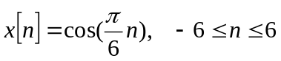
into the computer. How can you achieve this goal with C language? Wow, seems not easy, we need to define n, x, and the cosine function, then maybe using a for loop to achieve this goal. The good news is that MATLAB can make your life much easier, all what you need to do is using the following two lines of command:
(Note that: when you write code, it is a good practice to add comments that describe the code. Comments allow others to understand your code, and can refresh your memory when you return to it later. Add comments to MATLAB code using the percent (%) symbol. So for the Lab sessions, it is unnecessary to type the descriptions after the percent (%) symbol.)

>> n= -6:1:6 % n is a vector, containing the values of all the required n: all integers from -6 to 6
>> x= cos(pi/6*n) % x is also a vector, and contains the corresponding values of cos(pi/6*n)

After typing these commends into MATLAB, you can see the vectors n and x are both listed in the Workspace. The Workspace will temporarily save the data generated in MATLAB. Ok, now there is a discrete time signal x[n] saved in MATLAB, we really want to check it with a nice figure. Try to use the functions stem and plot to show the signal.
It is always true that you may be eager to know how to use stem and plot in MATLAB. It is time to know the built-in help facility. Just type

>> help stem
>> help plot

MATLAB will show you the introduction of these functions. However, if the name of the function is not known beforehand, and assuming that the internet is not available for a searching, you can use lookfor command.

Note the differences between the following commands:
>> plot(x) % check the start point on the x-axis of this plot
>> figure % use this command to open a new figure, otherwise the following curve will cover the previous one
>> plot(n,x) % Can you figure out what the x-axis is now corresponding to ?

After obtain a figure, you should add some labels on x-axis and y-axis, try the following
>> xlabel('n');
>> ylabel('x');
>> title('It is a good figure')

Practices 1:
a). Try to use the function subplot to draw all the curves of the following sinusoid waveforms in ONE figure with four sub-figures:
>> n=-5:0.2:5
>> x1=sin(pi/4*n);
>> x2=sin(pi/3*n);
>> x3=sin(pi/2*n);
>> x4=sin(pi/1*n);

b). If you want to check the differences between two curves, and want to show them in the same plot, try to use hold on command as follows. Make sure you understand the meaning of the following commands:
>> n=-5:0.2:5
>> x1=sin(pi/2*n);
>> x2=cos(pi/2*n);
>> plot(n,x1,'r');
>> hold on
>> plot(n,x2,'b');
>> hold off

Basic operations
We have learnt how to describe a signal using MATLAB. Now, let us study some useful functions in MATLAB. Typing the following commands and figure out the ‘function’ of these functions:

>> x = 1.2+3.4*j;
>> x_mag = abs(x);
>> x_p = angle(x);
>> x_r = real(x);
>> x_i = imag(x);
>> x_conj = conj(x)
>> x_round = round(x);
>> x_floor = floor(x);
>> x_ceil = ceil(x);

Well, usually the data will be given in a vector form or in a matrix form. Some basic operations you should know for these scenarios are listed as follows:
Scenario1: Vectors (1-D case)
>> a = [1:4] % a=[1 2 3 4]
>> b = [2:5] % b=[2 3 4 5]
>> c = a.*b % element by element multiplication
>> d = a'*b % 4-by-1 vector multiple 1-by-4 vector, results in a 4-by-4 matrix, what is the rank of this matrix?
>> e = a*b' %1-by-4 vector multiple 4-by-1 vector, results in a scalar

Think: What will happen if you type f = a*b ?

Typing the following and figure out how the function zeros works?
>> v=zeros(1,4)
Press the return key, you will see a 1-by-4 zero vector v=[0 0 0 0], then ,observe the following:
>> a = [1:4]
>> a_r = [v, a];
>> A_m = [v; a];
>> g1 = a_r (2:end) % a 1-by-3 vector. Find out how it is constructed.
>> g2 = a_r (2:length(a_r)) % check how to use the function length by yourselves

Scenario2: Matrices (2-D case)
>> y = [1-1j, 2+2j, 3-3j; 4+4j, 5-5j, 6+6j; 7-7j, 8+8j, 9-9j]
>> y_t = y. ' ; % Transpose matrix of y
>> y_h = y ' ; % Hermite matrix of y
Make comments on the differences between the matrices y_t and y_h.

Practices 2:
Have a look at the following table, which contains the information of players (stars) from team HEAT (All the information can be found in NBA official website):
Number | Name | Height (m) | Weight (kg)
1 | Chris Bosh | 2.11 | 107
3 | Dwyane Wade | 1.93 | 100
6 | LeBron James | 2.03 | 113
31 | Shane Battier | 2.03 | 102
34 | Ray Allen | 1.96 | 93
Assuming that you are the manager and have just learnt how to use MATLAB, cool!
Now your boss wants to know some facts on the heights of these players. Well, you can do the following:
First, save the heights of these five players into a vector:
>> heights =[2.11,1.93,2.03,2.03,1.96];
and find out the maximum value, minimum value and the average value by using the following functions:
>> max_height = max(heights)
>> min_height = min(heights)
>> ave_height = mean(heights)
Great, now you can tell your boss that the highest player enjoys a height of m and the average height for this team is m. Boss should to be very happy with this, but he may ask: what’s the number of the tallest player? What will you do now? Write down you idea and try to complete this mission.

By the end of this subsection, you should already have the ability to use MATLAB for describing signals. However, you may find that it is not convenient to use Command window for a coding and editing. Hence, for the following sections, we will learn how to generate an m-file in MATLAB and use it for a MATLAB programming.

Write up your first m-file
In the previous section, we have used MATLAB in a ‘basic mode’, in which each instruction is typed individually in the Command window. Now, it is time for us to switch into an ‘advanced mode’, that is to store the instructions or command in a file: m-file. In order to make MATLAB programming easier, we can set up an m-file and do the editing and debugging within it. An m-file can be a script and/or a function.
A script is a list of MATLAB commands that are saved in file with an .m extension.
For example, click the ‘new script’ button that is located on the top-left corner of the main screen, and enter the following lines (You have given the m-file with name ‘scriptexample.m’ in the folder “Lab1_student”, open it and ‘run’ it. Note that the ‘run’ icon is located on the up middle of the icon row.)
% An example for a script
n=-5:0.1:5
x1=sin(pi/4*n);
x2=cos(pi/4*n);
plot(n,x1,'r');
hold on
plot(n,x2,'b');
hold off
xlabel('n');
ylabel('x');
title('It is a good figure')
legend('sin','cos')

For such a script, you can name it as you wish, but remember, only with English characters and numbers.

A function in MATLAB is a special type of script file that can provide output arguments with a given input. So, yes, it is a kind of SYSTEM, and other users can call such a function with proper inputs. Recall the functions that are provided by MATLAB, such as max, mean, plot. In order to facilitate other users to call a function, a function file MUST follow a specific format and naming conventions. The first line of the function file must indicate the number of input and output, the name of the function. Remember that the name of the m-file must be same as the name of the function (as defined in the first line of the function).
For example, you have given the following function named: ‘functionexample’ (the m-file can be found in the folder “Lab1_student”.)
function [y]=functionexample(n,p)
% this function is used to plot a sin waveform,
% the inputs are: n, range of x-axis, p: a parameter to change the waveform
% output y is the corresponding data to the curve
y=sin(pi/p*n);
plot(n,y)
xlabel('n');
ylabel('y');
title('It is a good example')

It should be noted that you must add this function into the MATLAB current folder. A simple approach for this purpose is click the ‘run’ icon for this function and chooses to add it in the folder. Then, you can call this function in the Command window as follows:
>> n=[-5:0.2:5]
>> p=2
>> [y]=functionexample(n,p)

You may wonder: if other students want to use your function, is it possible for them to use help function to do it? The answer is positive. Try to type
>> help functionexample
You will see:
this function is used to plot the sin waveform,
the inputs are: n, range of x-axis, p: a parameter to change the waveform
output y is the corresponding data to the curve

It can be concluded that help actually takes the function name as the input and provide the print of the lines starting with a comment symbol (%) in the function as the output.

Now, try to solve the following problem

Problem
Write an m-file for computing
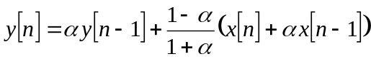
where 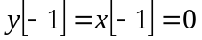, is a constant and 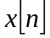 is given as follows:
>>n=0:1:249;
>>s=cos(0.021*pi*n)-0.75*cos(0.035*pi*n+pi/4);
>>e=3.5*cos(pi*n);
>>x=s+e;

Run your program with different values for alpha (say = 0.75 and = -0.75). And compare the outputs.

Hints: Note that, you have given the following pseudo-code for this problem (see the ‘p6pro_student.m’ file in the folder “Lab1_student”, in which two key instructions are missed; you should filling in this pseudo-code to make it work. Of course, is would be better if you can set up you own codes without using the provided materials.

function [y]=p6pro_student(x,n,alpha)
N=length(n);
y=zeros(N,1); % initialize output vector y

y(1)= % FIRST MISSING LINE

for loop=2:N % use for loop to calculate the rest of y
y(loop)= % SECOOND MISSING LINE
end
figure
plot(n,y)
title('y')

Transformations of the independent variable
In this section, we will show you an example with the powerful function Graphical user interface (GUI) in MATLAB.
Run “trnsfm.m” in the folder “Lab1” to open a GUI program depicting in Figure 1-1.
>>trnsfm

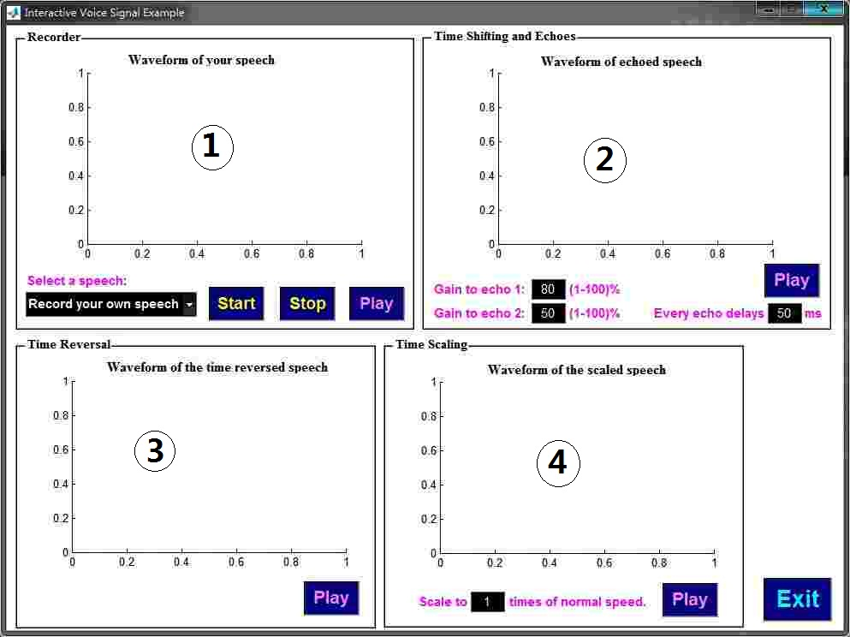
Figure 1-1 The interface of function trnsfm

This GUI experiment enables you to load an audio signal and do some transforming with it. You will see the audio signal with echoes, listen to the reversed audio signal and compare the audio signal with different time scaling factors. There are 4 main modules in the program.
Module 1: The “Recorder” module. In this module, you can record your own speech by setting ‘Record your own speech’ in the window of ‘Select a speech’. If you want to record your own speech, use the “START” and “STOP” buttons to record a period of your voice through your microphone. You can press the “PLAY” button to listen what you’ve recorded. In addition, this experiment allows you to select an existing audio signal, simply choose ‘singing’ or ‘speech: welcome’ in the window of ‘Select a speech’ to load a music signal and a speech signal, respectively.
Module 2: The “Time shifting and echoes” module. In this module, your voice was time shifted and added to the origin one. If 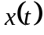 denotes the origin voice, you can press “PLAY” button to listen the following audio signal
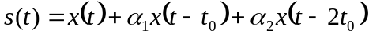,
where the blank for ‘Gain to echo 1’ is 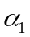, the blank for ‘Gain to echo 2’ is 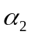and delay can be adjusted in the blank ‘Every echo delays’. Note that such an audio signal is constructed with original voice signal plus two time-shifted copies (echoes).
Module 3: The “Time Reversal” module. Here, you can hear the time reversed version of your voice by press the “PLAY” button.
Module 4: The final module is named “Time Scaling”. You can hear the time scaled version of your voice by pressing the “PLAY” button. The time scaling factor can be adjusted in the blank. Before you run this experiment, think how the audio signal will be changed with time scaling factors 0.5 and 2? Then, run the simulations and check if the signals follow your expectation.

Additional question:
Here, we present two additional questions for the students who have a spare time and want some challenges. ENJOY!

1：Given the following vectors:
>> a=[-3:3]
>> b=fliplr(a)
Check what has the function fliplr done to the vector a? Now you are required to generate a new vector b in the following way: replace the second and third elements in vector b with the last two elements in vector a. Hint: a(n:m) represents the n-th element to the m-th element of vector a.

2: Use MATLAB function ‘rand’ to estimate the value of .
Hint: You can use the function ‘rand’ to generate a large number of points in a certain area and then try to figure out the value of pi. For example, assuming we have a block whose four corners are located in (0,0), (0,1), (1,1), and (1,0), respectively. Then, the Coordinate of a point that is randomly located in this block with uniform distribution can be expressed as p=[rand(1),rand(1)]. If the number of such points is increasing, they will finally cover the whole block with uniform distribution.

Appendix: Some commonly used MATLAB commands
Functions:
abs(x) | absolute
cos(x) | cosine
sin(x) | sine
exp(x) | exponential
ezplot(x,y,z) | plot of symbolic function x for range y to z (optional)
fft(x) | (fast) Fourier transform
fftshift(x) | shifts Fourier spectrum such that 0 frequency is positioned at the center
figure(x) | opening of figure window number x
filter(x,y,z) | filtering the input z by a filter with transfer function x upon y
fir1(x,y,z) | designs FIR filter of order x with cutoff frequency y and the type z (optional)
fourier(x) | Fourier transform of symbolic function
ifourier(x) | inverse Fourier transform of symbolic function
ftrans2(x) | tranforms a 1-dimensional filter to a 2-dimensional filter
hold on | holds the previous plot when the next plot is drawn
imfilter(x,y) | filtering the input image x by filter y
imread(‘x’,’y’) | read image file x of type y
int(w, x, y, z) | integration of a function w with respect to variable x for limits y to z
plot(x, y, ‘z’) | plot y versus x graph in color z (optional)
recpuls(x, y) | rectangular pulse of width y (optional) evaluated at time instants x
sound(x,y) | playing the sound of array x with sampling rate y (optional)
waveread(‘x’) | reads wave audio file
[h,w] = freqz(b,a,n) | the frequency response vector h and the corresponding angular frequency vector w of the digital filter
[h,w] = freqs(b,a,n) | the frequency response vector h and the corresponding angular frequency vector w of the analog filter

Note:
It is useful to note that MATLAB ‘help’ may be used to find details of any function. For example,
>> help abs
will tell you what this instruction means and how to use it.

Experiment II: Time-domain Approach to LTI Systems

Objective
Enhance the understanding of the properties of LTI systems. Gain more knowledge on the concepts of convolution and impulse response.

Introduction
Convolution appears extensively in signal processing, communication and control engineering. It can be viewed as a description of the input-output relationship for an LTI system. In addition, it can also be considered as an operation performed between two arbitrary signals. Using this viewpoint, convolution can be used as a tool for analyzing the properties of signals or the processes that produced those signals.
The unit impulse response of a system is the response of the system to the unit impulse signal and it has particular significance when a system is LTI because it can completely characterize the system. The impulse response provides all of the information that is required to determine the output of an LTI system with any input signal.
If the unit impulse response of an LTI system is given by the signal h, then

For continuous-time (CT) system
The output signal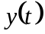 can be expressed as the convolution between the input signal and the unit impulse response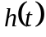. This operation can be written as the convolution integral,
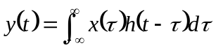 (1)
It is common to use the shorthand notation
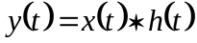 (2)

For discrete-time (DT) system
The output sequence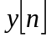 is given by the convolution of the input signal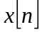 with the system impulse response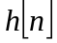. This operation can be written as the convolution sum,
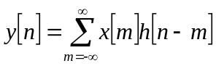 (3)
Again, the shorthand notation is
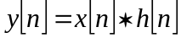 (4)
Write a program to evaluate the convolution integral/sum is not difficult. However, an alternate method called graphical convolution can be employed to provide valuable insight of the convolution process.
As this experiment is done with a digital computer, we will study convolution mainly in the DT scenario. Using the computer-aided graphical approach, it is often possible to visualize the result of a convolution by inspecting the input sequences. The method involves properly aligning two sequences on a common time axis, then multiplying them one by one, and finally adding up all these sequences. The following exercises introduce convolution and the associated concepts of LTI system and impulse response with computer simulation and real-time measurement.

Procedure

Convolution of sequences
In this section, we will apply Equation (3) to calculate the convolution of two sequences and to examine some important properties of convolution.

Convolution sum
Generate the sequence 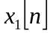 and 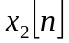.
>>x1=[1 -2 3]
>>x2=[1 2]
Convolve with and put the convolution sum 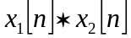 in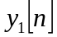.
>>y1=conv(x1,x2)
Convolve with and put the convolution sum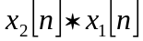 in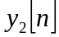.
>>y2=conv(x2,x1)
Check if the y1=y2? This trail indicates what property of convolution?
Set up a one-by-two sequence 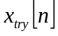 by yourself, and examine the values of 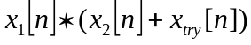 and 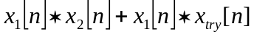.

An interpretation of convolution using superposition concept
This exercise presents another interpretation of the convolution operation. Carefully examine the convolution sum and observe that
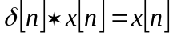
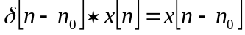
where 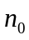 is an arbitrary integer.
Using each of the elements of the sequence x1, generate the following three sequences.
>>x11=[1 0 0]
>>x12=[0 -2 0]
>>x13=[0 0 3]
What is the summation of these three sequences?
Now convolve x11, x12, x13 with x2 and store the convolution sum in y11, y12 and y13, respectively. That is
>>y11=conv(x11,x2)
>>y12=conv(x12,x2)
>>y13=conv(x13,x2)
Add the resulting sequences y11, y12, y13 together and place the result in y3.
>>y3=y11+y12+y13
Is y3=y2=y1? Make some comments on this result.

Convolution illustrator
The code on convolution provided above is an experience of the specific convolution procedure. When it deals with the long signals, e.g. a filter excited by a long input signal, the program seems to be too tedious as it needs so many manual loops. Here is an interesting illustrator offering a step by step animation of the convolution. You can find the m-file “conv_animt.m” in the folder “Lab2”, and run this function in the MATLAB command window to open a GUI program.
>> conv_animt
Input signals and in vector forms, then press the ‘Display’ button in Figure 2-1. You can observe the process of convolution by pressing the “Enter” key on your keyboard.

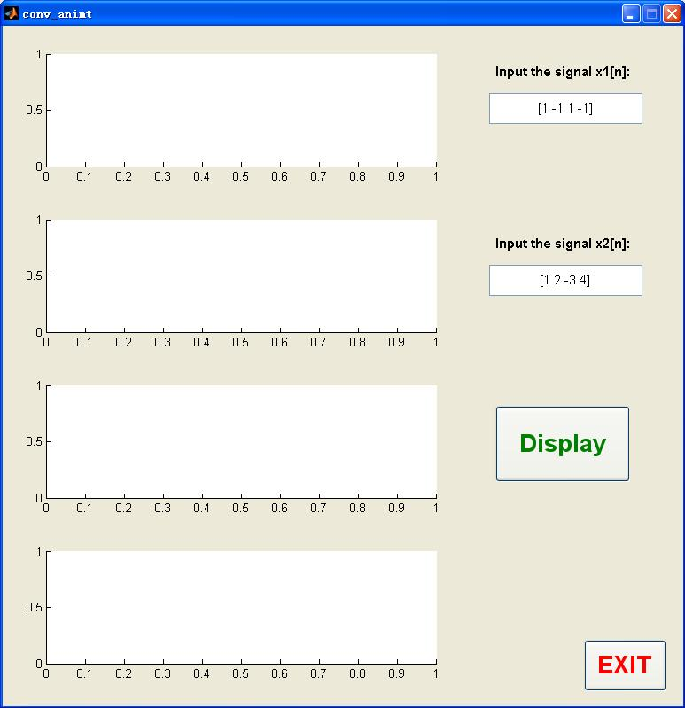
Figure 2-1 The interface of function “conv_animt”

System’s unit impulse response
The concept of the impulse response of a system is very important in signal processing, communication and control engineering.

A). Assuming that the unit impulse response of an LTI system can be expressed as
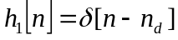, where 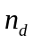 is a given positive integer.
It is known that such a system is usually named ideal delay system. Now, try to prove mathematically why it is given such a name.
Generate an input sequence as follows:
>> x=[1 2 3 4 5 6]
Set up the impulse response with 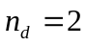 , that is
>>h1=[0 0 1]
Find out the corresponding output using ‘conv’ function.
>> y=conv(x,h1)
Does the output follow your expectation?

B). Now let’s go a little bit future, consider another LTI system with unit impulse response
>> h2=ones(1,length(x))
Check the output corresponding to the input x, what is the function of this system?
Problem
1). What will you do if the unit impulse response has a infinite length?
For example, there is a kind of LTI system known as adder, whose unit impulse response is given by
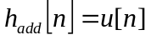
It is not possible to directly store such an unit impulse response in MATLAB, can you find out a way to let MATLAB operate with this system?
Tips:
1: Recall the definition of system: a system is an entity that is used to achieve a specified function. So you may first figure out the function of this system and than use a replacement.
2: Is it possible to employ the frequency domain approaches into this problem?

Implementation of music equalizer.
In this section, you can run “msceq.m” in the folder “Lab2” to open a GUI program. This program allows you to select an equalizer to process the music or speech. You can press the buttons to listen to the equalized music/speech with your earphone. The interface of function msceq is shown in Figure 2-2.
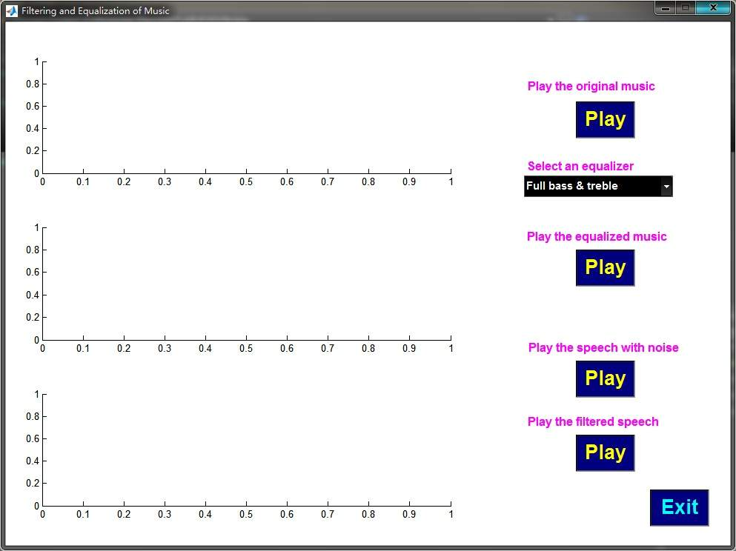
Figure 2-2 The interface of function “msceq”

If you want to know more about this program, the major steps for the above function are listed as follows.
First, load the audio signal stored in mymusic.mat in the folder “Lab2”:
>>[origin,fs,nbits]=wavread('mymusic.mat');
Then, you can listen to the original audio signal with your earphone by using the command:
>>wavplay(origin,fs);
Second, load the unit impulse response of the system stored in a.mat file. To load the unit impulse response and make it a row vector, using:
>>load speech;
>>b=speech’;
Third, the speech can now be transformed by using different equalizers:
“classical”, “popular”, “full_bass”, “full_bass_treble”, “full_treble”, “hp_filter”, “lp_filter”, or “rock” , each corresponding to a different equalizer.
Note that equalize the original audio is actually calculate the convolution as follows:
>>eqlzed(:,1)=conv(origin(:,1),b);
>>eqlzed(:,2)=conv(origin(:,2),b);
Finally, you can listen to the equalized audio signal with your earphone.
>>wavplay(eqlzed,fs); % play the equalized audio signal

Graphical convolution (Optional)
(This part is for those who are interested in becoming an expert on MATLAB programming. If you are one of them, please study the following materials by yourself. )
Graphical convolution is a straightforward and intuitive procedure to evaluate the convolution sum without the aid of a computer. The method is motivated by recognizing that the term 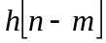 in the convolution summation (3) can be interpreted as a signal in the variable m with n interpreted as a shift parameter. Since =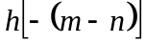, it is a time-reversed copy of 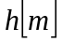 that is followed by n samples of shift on the m-axis. Thus, given , can be obtained by first reflecting the signal on the m-axis about the origin to form 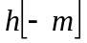 and shifting it n samples to the left if n is negative or n samples to the right if n is positive. The convolution at sample n can now be obtained by firstly display 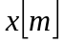 and on a common m-axis, then multiply the two aligned sequences on a point-for-point basis, and finally sum up these products. For different values of n, you only need to repeat this procedure.
In this exercise, the two sequences in Section 1 can be used.
You can sketch the sequences on paper for reference.

The reversed sequence
Reflect the sequence x2 about the origin and store the reflected sequence in x2_rev
>>x2_rev=fliplr(x2);
Sketch the reversed sequence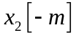 (together with x1 and x2)
>>subplot(3,1,1)
>>stem(x1);
>>subplot(3,1,2)
>>stem(x2)
>>subplot(3,1,3)
>>stem(x2_rev)

The time shifted sequence
To find 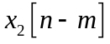 at an arbitrary value n=n₀, shift the reflected sequence n₀ samples to the right for n₀>0 or |n₀| samples to the left for n₀<0. The shifted sequence is stored in x2_rev_shift.
Initialization of some variables first
>>N1=length(x1);
>>N2=length(x2);
>>result=zeros(1,N1+N2-1);
>>x1_filled=[x1 zeros(1,N2-1)];
Given n0, shift the reversed sequence,
If n0<N2, type
>>x2_rev_shift=[x2_rev(N2-n0:N2) zeros(1,N1+N2-1-n0-1)];
otherwise, type
>>x2_rev_shift=[zeros(1,n0+1-N2) x2_rev(1:N2) zeros(1,N1+N2-1-n0-1)];
Note that the result has a length smaller than N1+N2-1, so n0 has a range from 0 to N1+N2-2!

Multiplication and add
According to the convolution equation, the two aligned sequences should be multiplied pointwise and added them up.
>>result(n0+1)=sum(x1_filled.*x2_rev_shift);

Plot
Repeat the processes until all points in the result are computed. The repeating part begins from “Shift the reversed sequence” (n0 from 0 to N1+N2-2). Finally, it is time to sketch them
>>n=0:N1+N2-2;
>>subplot(2,1,1);
>>stem(n,x1_filled);
>>hold on;
>>stem(n,x2_rev_shift,'r');
>>subplot(2,1,2);
>>stem(result);

Additional question:

Can you use a matrix expression to show a convolution between two sequences?
In many academic papers, you may find the input-output relation of an LTI system is expressed by a matrix-form equation as follows:
where is the input vector, is the output vector, 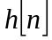 is the impulse response of an LTI system, 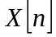is a matrix that is constructed from vector and 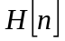is a matrix that is constructed from vector.
Firstly, determine the structure and the size of the matrix and, i.e. how to generate these matrices.
Then, design a four-by-1 impulse response vector and a three-by-one input vector by yourself, examine your results with MATLAB.
Make some comments on the complexity of the convolution operation (how many additions and multiplications are required for such an operation)

Experiment III: Introduction to MATLAB Spectral Analysis and Filtering

Objective
To learn the Fourier transform of signals, filtering and its applications in MATLAB environment.

Introduction

Continuous-time signal and its Fourier transform
A continuous-time signal  is a function of time , where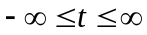. This signal may be represented in frequency domain using the continuous-time Fourier transform (CTFT). Its Fourier transform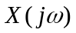, known as the spectrum, is defined as
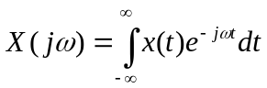
In general, the spectrum of any signal is complex valued.
Fourier representation is revertible. That means the signal can be obtained from its spectrum using the inverse Fourier transform, defined as
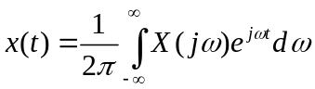

Procedure

Rectangular pulse

Plot time-domain signal
Find out the Fourier transform of the window signal (rectangular pulse) defined below
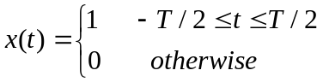
MATLAB function rectpuls.m generates a rectangular pulse for plotting. This function requires a time array and the pulse width T. First, let us define a time array, for example from -10 to 10 in steps of 0.1, using the array construction “start-value: step: end-value”:
>> tarray=-10:0.1:10;
Then, we can define a width T, for example, let T=2:
>> T=2;
Now, rectpuls(tarray, T) is the desired signal. Plot this signal using the plot function:
>> S=rectpuls(tarray,T)
>> plot(tarray, S);
>> axis([-10 10 -0.2 1.2])
Suggested extension:
- Using functions xlabel and ylabel, you may add properties labels to the x and y axes of your plot. MATLAB “help” may be used to find more details.

Fourier transform and its plot
The Fourier transform of the rectangular pulse is obtained by the Fourier transform integral. Define variables t and f as follows:
>> syms t;
>> syms f;
Now, 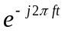 can be describes as exp(-j*2*pi*f*t) in MATLAB, where exp denotes the exponential operation. This entity is integrated for –T/2 to T/2 with respect to x using int.m function to obtain the Fourier transforms, say F can be obtained as follows.
>> F=int(exp(-j*2*pi*f*t), t, -T/2, T/2);
Use function ezplot to plot F for frequency -2 to 2.
>>ezplot(F,-2,2);
Make some comments on the figure you have just obtained, is this figure follows your expectations?

Suggested extension:
  - Repeated plotting the signal and the spectrum for different values of T. Using the hold on function, you may plot two or more signals or spectrums on the same plot for comparison. The following code will plot two pulses of widths 2 and 5 on the same plot, where the last argument of plot specifies the color as r (red) and b (blue):
>> T=2;
>> S1=rectpuls(tarray,T);
>> plot(tarray,S1,'r')
>> hold on;
>> T=5;
>> S2=rectpuls(tarray,T);
>> plot(tarray,S2,'b');
  - When the width (in time) of the rectangular pulse is increased, what happens to the width of the frequency spectrum?

The entire procedure 1.1 is written in a file “E3_rect_pulse_3.m” in the folder “Lab3”.

Frequency response of the system
The frequency response of the system is the gain of the system to different single frequency signals. The single frequency signal can be obtained using function cos.
>> fs=1000; % the sampling frequency Hz
>> t=0:1/fs:2; % time array
>> f=2; % the analog frequency of input signal
>> x=2*cos(2*pi*f*t); % to generate the analog single frequency % signal
>> fc=50; % the cutoff analog frequency of the filter
>> N=20; % the order of the filter
>> [b]=filter_sys(N,fc,0) % the low pass filter
>> y = filter(b,1,x); % to obtain the response to the input signal x;
>> plot(y)
The response to the input signal is saved in y. Plot y and record the magnitude of the output signal. Then the magnitude response of the filter at this particular frequency f can be obtained.

Here we use a function filter_sys .m to generate a filter.
[b]=filter_sys(N,fc,para).
The parameters:
N: the order of the filter; fc: the cutoff frequency Hz of the filter.
para: para=0, the lowpass filter; para=1, the high pass filter;
b: the coefficients of the filter;
You also can change the order, cutoff frequency and filter type of the filter.

Problem
Measure the magnitude response of the same filter at those frequency points given in Table 1. Through the plot of output y, obtain the output magnitude and fill it in the Table. The magnitude response can be computed by
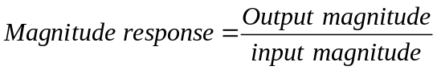

Table 1 Measuring the magnitude response of an LTI system using a sinusoidal input signal
Frequency(Hz) | 0 | 10 | 20 | 25 | 35 | 40 | 45 | 50 | 55 | 60 | 65 | 70 | 75 | 80 | 90
Input magnitude
Output magnitude
Magnitude response
You can follow two approaches to finish Table 1:
Method A: Repeat the whole process provided above for frequency f.
Method B: based on the process, write an m-file and let the compute to do the job for you.
Are you interested in writing an m-file for the above process? Believe in yourself, you can make it!

The m-file freq_response.m is provided for lecturers only. See How to use freq_response.m.txt.

Filtering and its applications to real-life signals
When the signal is processed through a filter, the filter passes (retains) some of the signal’s frequencies, but stops (removes) other frequencies. Therefore, the output signal does not have all the frequencies of the input signal.
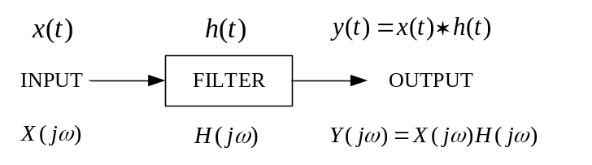
Figure 1. Filtering system

A low pass filter with a cut-off frequency of 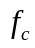 passes all frequencies from 0 to , and stops all frequencies from to 1. Here frequencies is discrete-time normalized cyclic frequency and has a range 0 to 1. Therefore, the spectrum of the input signal and the output signal will be the same for the range 0 to , but the spectrum of the output signal will be zero in the rang to 1. A high pass filter does the opposite of a low pass filter, stopping all frequencies from 0 to , and passing all frequencies from to 1.
Think:
Why the upper bound of the frequency is 1? Why we include such normalization for real-life signal processing?

Filter
MATLAB function firl may be used to obtain a filter. For example, to obtain a low pass filter with order 20 (typical choice) and cutoff frequency of 5000Hz, use:
>> fs=16000; % sampling frequency
>> fc=5000; % the cutoff analog frequency(Hz) of the filter
>> wc=2*fc/fs; % the normalized digital frequency
>> myfilter=filter_sys(20,wc,0);
where the impulse response of the filter is stored in an array named myfilter.
The high pass filter can be obtained as follows,
>> myfilter=filter_sys(20,wc,1);

The function freqz can be used to get the frequency response of the filter. In addition, it can provide the amplitude and phase responses of the filter.
>> [H,w]=freqz(b,1,2^10,fs);
>> plot(w,abs(H));
>> plot(w,angle(H));

If you want to know how to design the lowpass and highpass filter, the detailed program is saved in the filter_sys.m in the folder “Lab3”.
Advertisement: Design methods for classical digital filters will be detailed in a course called ‘Digital signal processing’ in next term.

Filtering of Speech
You can do
The MATLAB code for the filtering of speech is the function:
[S_in,S_out]=E3_speech_Filt( )
The parameters:
N : the order of the filter;
fc : the cutoff frequency of the filter Hz;
para: to choose the filter type: para=0 is the low-pass filter, para=1 is the high-pass filter;
para=3 is the band-pass filter, para=4 is the band-stop filter;
S_in: the returned parameter where the original speech is saved;
S_out: the returned parameter where the filtered speech is saved;

For example
In the MATLAB window, you type
>>[S_in, S_out]=E3_speech_Filt();
Then type input the parameters:
the order of the filter: 20
the filter type:0-lowpass, 1-highpass, 2—bandpass, 3-bandstop: 0
the cutoff frequency of the filter Hz: 5000

which means the order of the filter is 20, and the cutoff frequency of the low-pass filter (para=0) is 5000Hz. There are three figures you can obtain, one is the amplitude and phase response of the filter, one is the time-domain signals that consist of original speech signal, noised speech and filtered speech, the last one is the spectrum of the original, noised and filtered speech.
You can also use the function sound as in Section 3.2.2). Listen to the speech with your earphone.
>>sound(S_in,16000);
>>sound(S_out,16000);

If you want to know the detailed code about this function, see the file E3_speech_Filt.m in the folder “Lab3”. The further explanation is as follows.
3.2.1 Input and output speech
For the first filtering application, a noised speech file will be used. The frequency of the noise signal is beyond 6000Hz. Read the speech file “f1_16noisespeech.wav” into an array S_in using the function wavread:
>> S_in=wavread('f1_16noisespeech.wav');
Now filtering the input array S_in with a filter of your choice using the function filter to obtain the output array S_out:
>> S_out=filter(b,1,S_in);
3.2.2 Listening comparison
Listen to the input speech using the function sound, whose second argument is the sampling rate of 16000 samples/second:
>> sound(S_in,16000);
>> sound(S_out,16000);
Also listen to the output speech. Can you hear the effect of filtering?
You can also compare with the original speech which is in the file “f1_16”.
>> S_ori= wavread('f1_16.wav'); % the original speech
>> sound(S_ori,16000);
3.2.3 Spectrum comparison
It is also possible to compare the input with the output spectrum. Discrete-time Fourier transform (DTFT) of the input may be found using the function fft (fast Fourier transform).
>> [r c]=size(S_in);
>> NL=r*c; % length of the speech
>> L=fix(NL/2); % half of the sequence
>> X1=fft(S_in);
>> X2=X1(1:L);
>> X3=abs(X2);
Repeat the above three steps for output array S_out and original speech S_ori, and use a different name, say Y3 and y3;.
Now X3, Y3 and y3 may be plotted using the plot function. A frequency array farray is defined and used in the plotting function to obtain proper frequency labeling (in Hz) on the horizontal axis.
>> f=0:1:L-1;
>> farray=f*fs/NL; % frequency array
>> Subplot(3,1,1);
>> plot(farray,y3);
>> subplot(3,1,2);
>> plot(farray,X3,'r');
>> subplot(3,1,3);
>> plot(farray,Y3,'b');

Suggested extension:
- Choose different filter parameters and compare the output by listening as well as by plotting its spectrum. Make some comments on how to compare the performance of the filter with different parameters?
- By repeating the trail, determine the lowest cut-off frequency of low pass filter such that the speech is still distinguishable (understandable).
- Another noised speech is in the file “f1_16_sin_noise”. According the above process, try to filter the noise. You can determine the filter type to be used after analyze the spectrum of the noised speech.

Filtering of Image
3.3.1 Input and output image
For the second filtering application, read an image file “lena.tif” and save it in an MATLAB array inp2 using the function imread as follows:
>> inp2=imread('Lena.tif');
As in section 3.1), choose one filter and name it myfilter. Since image can be considered as two-dimensional signals, the filter is required to be transformed into two-dimensional by using ftrans2:
>> myfilter2=ftrans2(myfilter);
Filtering may be done somewhat similar to section 3.2.1) except using the image filtering function imfilter:
>> outp2=imfilter(inp2,myfilter2);
3.3.2 Viewing comparison
In a new figure window, display the input image using the function imshow:
>> imshow(inp2);
In another figure window, display the output image. Can you see the effect of filtering?
Suggested extension:
- Choose different low pass filter parameters or high pass filter and compare the output by viewing.
The reference MATLAB code is in the file ‘E3_image.m’ in folder “Lab3”.

Experiment IV: Signal Sampling and Reconstruction

Objective
Learn the sampling theorem for signals. Know how to reconstruct the continuous-time signals in MATLAB environment.

Introduction

Sampling theorem (Nyquist Theorem):
The sampling mechanism is depicted in figure 4-1. The periodic impulse train 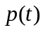 is referred to as the sampling function, the period 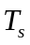 as the sampling period. In the time domain and frequency domain:
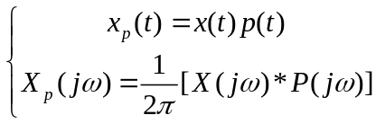

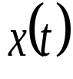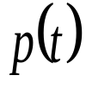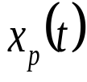
Figure 4-1 the impulse-train sampling

We use,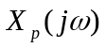 and 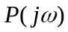 to denote the FT of, 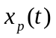 and.
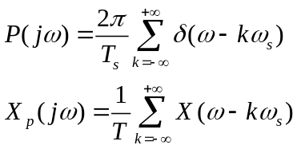
is a periodic function consisting of a superposition of shifted replicas of .
The Sampling theorem can be stated as follows:
Suppose is band-limited
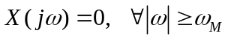
Then can be recovered from its samples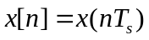, if
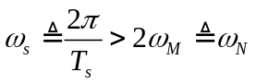
where 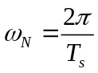 is usually referred as to the Nyquist frequency.
When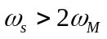, there is no overlap between the shifted replicas of, while with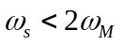, there is overlap.

Reconstruction of the signals
For a band-limited signal, if the sampling instants are sufficiently close, then through the low-pass filter 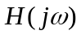 with the cutoff frequency of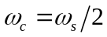, the signal can be reconstructed exactly. The system of sampling and reconstruction is shown in figure 4-2.
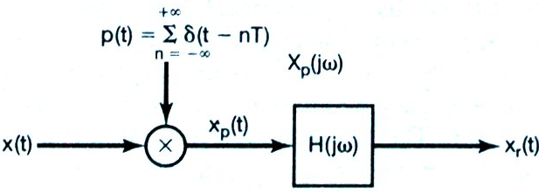
Figure 4-2 the system of sampling and reconstruction

Ideal reconstruction
Ideal band-limited interpolation using sinc function:
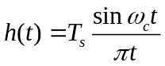
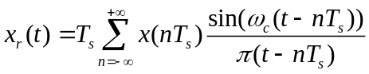

Zero order hold (ZOH)
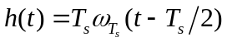
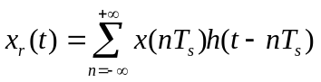

First order hold
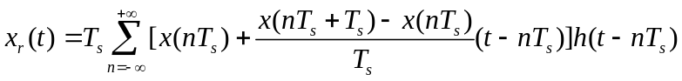

Procedure

Sampling of Continuous-time Signals
You can do:
The MATLAB function for the sampling of continuous-time signals is
sampling(signal_f, over_f,under_f)
The parameter:
signal_f： the frequency of the analog signal;
over_f ： the oversampling frequency
under_f： the undersampling frequency
You can change these three parameters and observe the time-domain and frequency-domain relationship between the analog and the sampled signal.
For example
In the MATLAB Command window, you can type
>>sampling(20,60,30).
It means you have chosen the signal frequency as 20Hz, the oversampling frequency is 60Hz, and the undersampling frequency is 30Hz. There are two figures you can see. One figure is the time-domain signal; the other shows the spectrums of the analog signal and the sampled signal.

If you want to know the detailed MATLAB code for the above function, you can see the file sampling.m in the folder “Lab4”. The following is the further explanation.

Plot the sampled signal
Considering the sinuous signal with frequency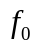, for example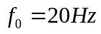:
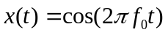
To plot a continuous-time, we can sample the signal with quite high frequency rate,
>> signal_f=20;
>> t=1:1/(50*signal_f):0.5;
>> x=cos(2*pi*signal_f*t);
>> plot(t,x);

Then the signal is sampled with two frequencies. One is oversampling frequency, for example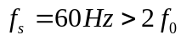, and another is undersampling frequency, for example, 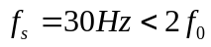, which do not satisfy the sampling theorem. Define the sampling time array, tss=0:1/sampling_f:0.5，the sampled signal is obtained by
>> xs=cos(2*pi*signal_f*tss);
Plot the sampled signal, using the function stem.
>> stem(tss,xs);

Plot the spectrum
In this MATLAB function, for analyzing the spectrum of the continuous-time signal and the sampled signal, we have used the MATLAB function fft and fftshift. The detailed information can be obtained by typing
>> help fft
The spectrum of signal x can be obtained by the below MATLAB code, which have returned to X.
>> X=fftshift(fft(x))*T;
Repeat the same steps for oversampled signal and undersampled signal.
when 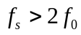, no aliasing occurs, the frequency is identical to the original signal frequency, since 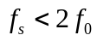 whereas aliasing does occur, and the aliasing frequency is located at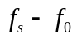.

Reconstruction of the Continuous-time Signals
You can do:
Run “signal_recons.m” in the folder “Lab4” to open a GUI program. The MATLAB function signal_recons is depicted in figure 4-3.
>> signal_recons
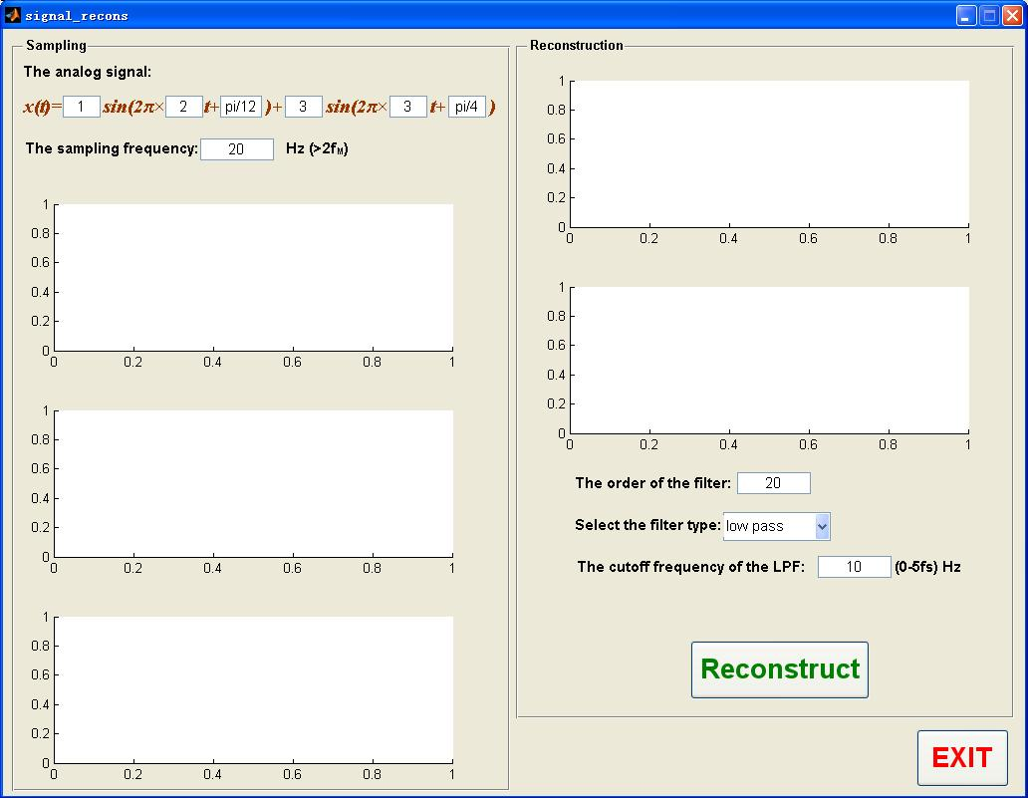
Figure 4-3 Interface of the function “conv_animt”

Here the analog signal is the sum of two sinusoidal signals. You can adjust their amplitudes, frequencies and phases directly in the user interface. Press the button “Reconstruct”, you can see 5 waveforms, make some comments on these waveforms and see if they are all following your expectation.
The further explanation for the program is given as follows.

Ideal reconstruction
Interpolation using the impulse response if an ideal low pass filter as shown in eq.(4) is referred to as band limited interpolation. Considering the sinuous signal with frequency , the sampled signal 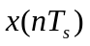is obtained using the sampling frequency 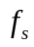, the reconstruction of the signal can be plotted according to eq.(4).

Zero-order reconstruction
Plot the zero-order reconstruction signal using the function stairs:
>>stairs(t,x);

First-order reconstruction
The first-order reconstruction signal can be plotted using function plot:
>>plot(t,x);

Smooth the plot (optional)
Can you smooth the plot of Zero-order and First-order reconstructed signal? And how?
Here, we provide a possible solution, in which the low-pass filter is employed. Use the MATLAB function firl to obtain the low-pass filter. You can change the cutoff frequency. If zero-order reconstructed signal is denoted as x2.Plot and compare the zero-order reconstructed signal and the filtered signal. Define t_zero as the time array. Try the following comments:
>>b=fir1(20,wc,'low');
>>x2_filter=filter(b,1,x2);
>>plot(t_zero,x2);
>>hold on;
>>plot(t_zero,x2_filter);

Suggested extension:
- Choose different sampling frequencies and observe the analog signal and the ideal reconstructed signal. Testify the sampling theorem.
- Change the cutoff frequency of the filter and the filter type (para=0, low pass, para=1, high pass) to observe the effect of the filter on the zero-order reconstructed signal, and think about the reason of the time delay.
- Try to apply the sampling theorem and the reconstruction means to the music or pictures, compare the reconstructed signal with the original signal under different sampling frequency.

